**SURVIVAL ANALYSIS**

**Business Problem** = ﻿﻿﻿Perform Kaplan Meir analysis for the given data and get the life table.

* **Name of the File: -** Patient.csv
* **Size of the File: -** 4 KB
* **Req. Data: -** 10 Observation, 2 Variable
* **Column Name: -** Followup, Eventtype

**Exploratory data Analysis** =

* **Outliers: -**  Profit variable having outliers.
* **Missing Value: -** Data don’t have Missing Values

**﻿Fitting Kaplan Meier Fitter =**

* 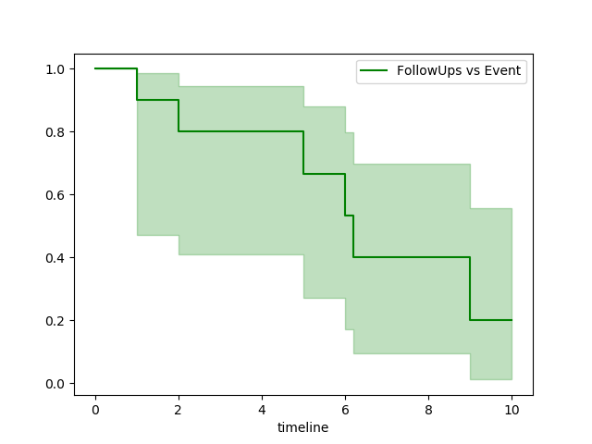**﻿Time-Line Estimations Plot: -**

From above plot we can see that probability of patients survival with respect to time

**Python code file**: - [Patient Survival Analysis.py](https://github.com/nilaydeshmukh0/Survival-Analysis-or-Time-To-Event-Analysis/blob/master/Patient%20Survival%20Analysis/Patient%20Survival%20Analysis.py)